8.104: a) Including the extra force, Eq. 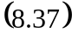 becomes

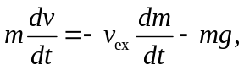
where the positive direction is taken upwards (usually a sign of good planning). b) Diving by a factor of the mass 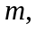

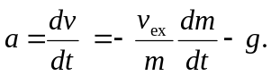

c) 20 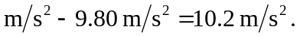 d) 3327 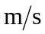 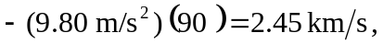 which is about three-fourths the speed found in Example 8.17.

